

**User Guide :**

**STAKEHOLDER INTELLIGENCE AND PERFORMANCE DASHBOARD**

**Purpose** –

The dashboard helps people who care about the business (stakeholders) see how money is made, who’s performing well, what’s risky, and how things are changing over time, so they can take smart actions.

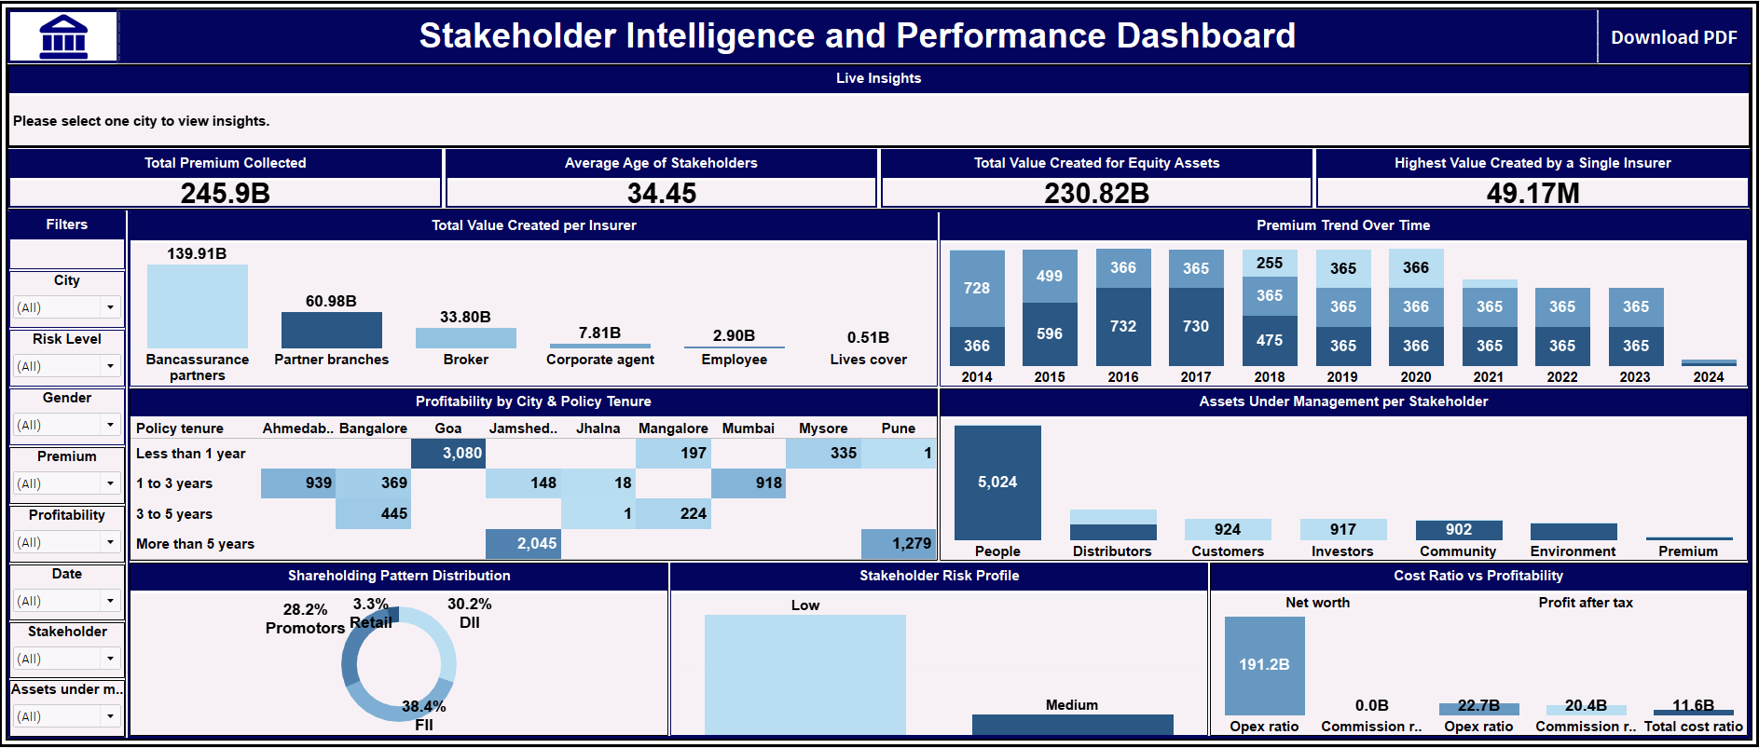

**Requirements –**

1. **Charts & Visuals:**

* **Value Created by Insurers:** Compare which insurers are bringing the most value to the company.
* **Premium Trends Over Time:** Track how premium collections have increased or decreased across years.
* **Shareholding Distribution:** See how ownership is split among retail, FIIs, DIIs, and promoters.
* **Cost Ratio vs. Profitability:** Understand how spending impacts profit across different segments.
* **Profitability by City & Tenure:** Use heatmaps to find which city-policy combinations are most or least profitable.
* **Assets Under Management:** Visualize where stakeholder investments are placed (equity or debt).
* **Stakeholder Risk Levels:** Classify stakeholders as High, Medium, or Low risk based on cost and profit data.

1. **Key Performance Indicators (KPIs):**

* **Total Premium Collected:** Shows the overall amount of premium gathered across all stakeholders.
* **Average Stakeholder Age:** Displays the average age of all stakeholders for demographic insight.
* **Value from Equity Investments:** Highlights total value created by stakeholders managing equity assets.
* **Top-Performing Insurer:** Identifies the insurer that contributed the highest value to the company.

1. **Filters:**

* **City:** Narrow down data to specific locations using a dropdown filter.
* **Gender:** Filter data to compare insights between male and female stakeholders.
* **Date:** Select a custom date range to analyze trends over a specific period.
* **Risk Level:** View stakeholders based on their risk category — High, Medium, or Low.
* **Stakeholder Type:** Focus on specific groups like insurers, investors, or customers.
* **Premium Type:** Filter by how the policy was paid (e.g., first year, renewal, single).
* **Profitability Type:** Choose metrics like net worth, profit after tax, or ROI.
* **Assets Under Management (AUM):** Filter by investment type such as equity or debt.

1. **Interactivity:**

* **Click to explore more:** Clicking on any chart will update the rest of the dashboard automatically.
* **Hover for details:** Just hover your mouse to see extra info like exact numbers and comparisons.
* **Everything updates live:** Whenever you use a filter, all charts and metrics change instantly to match.

1. **Export Options:**

* **Download as PDF:** Click one button to save the current dashboard view as a PDF.
* **What you see is what you get:** The PDF shows exactly what’s on screen, including charts, filters, and KPIs.
* **Watermark included:** The exported file has a light company logo for a professional look.

1. **User Access:**

* **Designed for different users:** The dashboard is built with role-based access in mind — so in future, different users can see only what's relevant to them.

**Usage Instructions:**

**Navigating the Dashboard:**

* Use filters at the top or side to explore data by **city, gender, date, stakeholder,** etc.
* Click on any chart to update the rest of the dashboard automatically.
* Hover over charts to see extra info like numbers, trends, and helpful tooltips.

**Exporting Data:**

* Click the **Export to PDF** button on the top menu.
* It saves your current view, including selected filters and data.
* The PDF will have all the charts and a light watermark with branding.

**Role-Based Viewing (Planned):**

In future versions, the dashboard will show different data based on the user’s role - for example, insurers will see only insurer-related data, and stakeholders will see only their own.